Sri shanmugha college of engineering and technology

Pullipalayam, Sankari

DEPARTMENT OF BIOMEDICAL ENGINEERING

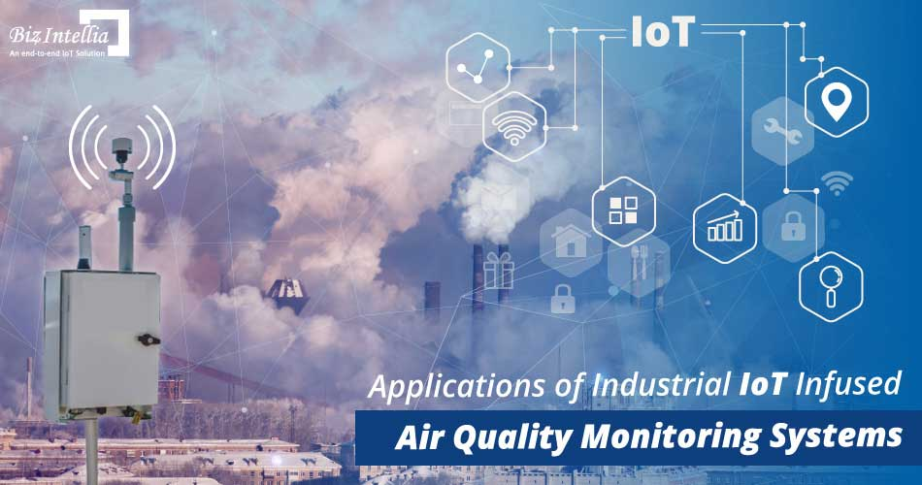 Phase 5 project document submission

Team members

SOWMIYA M – 732721121049

PAVITHRA C T – 732721121038

SWETHA G K – 732721121054

KANISHKA S – 732721121021

NISHANTHINI T – 732721121034

INTRODUCTION

Air is a growing issue these days. It is necessary to monitor air quality and keep it under control for a better future and healthy living for all. Here we propose an air quality monitoring system that allows us to monitor and check live air quality in a particular areas through IOT. System uses air sensors to sense presence of harmful gases/compounds in the air and constantly transmit this data to microcontroller. The sensors interact with microcontroller which processes this data and transmits it over internet. This allows authorities to monitor air pollution in different areas and take action against it.

PROBLEM STATEMENT

Air quality is a critical environmental concern affecting the health and well-being of communities worldwide. Monitoring and maintaining high air quality standards are essential to ensure the safety and health of the population. Air quality management within the chemical industry is a critical concern due to the potential release of hazardous air pollutants that can harm both human health and the environment. The problem lies in the need for effective and comprehensive air quality monitoring and control systems within chemical plants to ensure compliance with environmental regulations, safeguard the well-being of employees, and prevent the release of toxic emissions.

INNOVATION

Innovations in chemical industry air monitoring are essential to enhance safety, compliance, and sustainability. To reduce the air leakage at chemical industry by our project is been done by the usage of sensors and methodology**.**  Internet of Things low-cost air quality monitoring system. The system utilizes air quality and carbon monoxide sensors for monitoring gaseous pollutants. Moreover, the system utilizes an Arduino Nano development board equipped with a Wifi module to effectively send readings to a Thing Speak online channel platform for instantaneous and real-time display of air quality.

DESIGN COMPONENTS

* Arduino uno
* Microcontroller ATmega 328p
* Waspmote sensor
* ESP8266 Wi fi module
* MQ135 sensor
* MQ7 sensor
* Buzzer
* LCD screen

PIN CONNECTION

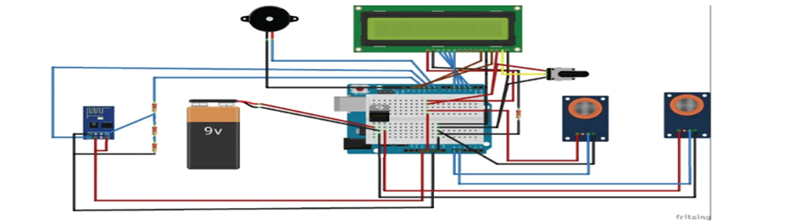

The first unit is a power supply unit, which consists of a DC jack and a regulator. The second unit is the sensing unit, which consists of an air quality sensor and a carbon monoxide sensor. Then, the third unit is the control unit, which consists of the Arduino Uno atmega microcontroller. The fourth unit is the communication unit, which consists of a WiFi module used to transfer the air quality status from the control unit to the IoT platform. Finally, the fifth unit is the output unit, which consists of an LCD, a buzzer.

OVERVIEW OF THE PROCESS

**Selection of Monitoring Stations:**  Strategic locations are chosen to set up monitoring stations, considering factors such as proximity to pollution sources, population centers, and geographical features that may influence air circulation patterns.

**Data Collection:** Monitoring stations use specialized equipment and instruments to collect data on various air pollutants, including particulate matter, ozone, carbon monoxide, sulfur dioxide, nitrogen dioxide, and volatile organic compounds. Data collection can be continuous, semi-continuous, or periodic, depending on the specific monitoring requirements and objectives.

**Data Processing and Analysis:** The collected data undergoes rigorous processing and analysis to derive meaningful insights into air quality trends, pollutant concentrations, and potential health risks. Statistical techniques and modeling may be employed to interpret the data and identify patterns or anomalies.

**Quality Assurance and Quality Control (QA/QC):** Rigorous QA/QC measures are implemented to ensure the accuracy, reliability, and consistency of the collected data. This involves regular calibration of monitoring equipment, adherence to standard operating procedures, and validation of data against established quality standards and guidelines.

**Data Reporting and Dissemination:** The analyzed data is compiled into comprehensive reports and made accessible to the public, relevant stakeholders, and policymakers. This transparency helps raise awareness about air quality issues and facilitates informed decision-making for implementing effective air quality management strategies.

**Impact Assessment and Policy Formulation:** The findings from air quality monitoring are used to assess the potential environmental and health impacts of air pollution. Based on these assessments, policymakers can develop and implement targeted policies, regulations, and interventions aimed at reducing pollution levels and improving overall air quality.

**Long-Term Monitoring and** **Trend Analysis:** Continuous monitoring and trend analysis allow for the evaluation of the effectiveness of implemented measures and the identification of emerging air quality challenges. Long-term data trends help in forecasting future air quality scenarios and adapting strategies to meet evolving environmental and public health needs.

BLOCK DIAGRAM

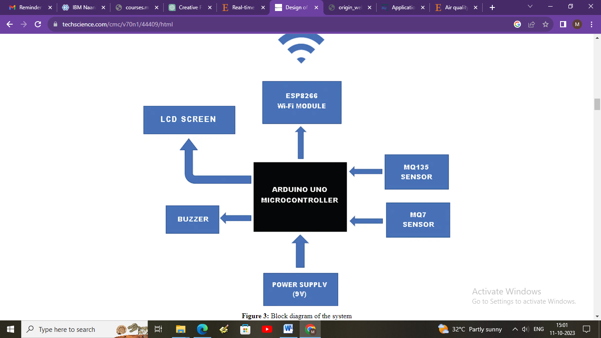

PROGRAM

// Define the analog pins for the MQ135 and MQ7 sensors

int mq135_analog_pin = A0;

int mq7_analog_pin = A1;

void setup() {

Serial.begin(9600);

}

void loop() {

// Read the analog values from the MQ135 and MQ7 sensors

int mq135_sensor_value = analogRead(mq135_analog_pin);

int mq7_sensor_value = analogRead(mq7_analog_pin);

// Convert the analog values to voltages

float mq135_voltage = (mq135_sensor_value / 1024.0) * 5.0;

float mq7_voltage = (mq7_sensor_value / 1024.0) * 5.0;

// Calculate the resistance of the sensors using a voltage divider formula

float mq135_resistance = ((5.0 - mq135_voltage) / mq135_voltage) * 10.0;

float mq7_resistance = ((5.0 - mq7_voltage) / mq7_voltage) * 10.0;

// Use the resistance values to estimate air quality for MQ135 and MQ7

int air_quality_mq135 = getAirQuality(mq135_resistance);

int air_quality_mq7 = getAirQuality(mq7_resistance);

// Print the results

Serial.print("MQ135 Air Quality: ");

Serial.print(air_quality_mq135);

Serial.println(" ppm");

Serial.print("MQ7 Air Quality: ");

Serial.print(air_quality_mq7);

Serial.println(" ppm");

delay(2000); // Delay for 2 seconds between readings

}

// Function to estimate air quality based on sensor resistance

int getAirQuality(float sensor_resistance) {

// You will need to calibrate your sensor based on its datasheet

// These values are for reference and may need adjustments

if (sensor_resistance <= 25) {

return 10000; // Very poor air quality

} else if (sensor_resistance <= 50) {

return 8000; // Poor air quality

} else if (sensor_resistance <= 100) {

return 5000; // Moderate air quality

} else if (sensor_resistance <= 200) {

return 2000; // Good air quality

} else {

return 1000; // Excellent air quality

}

}

OUTPUT

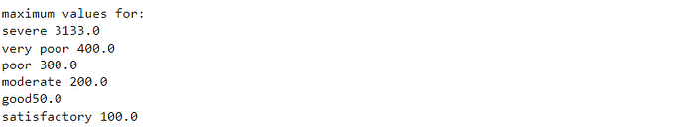

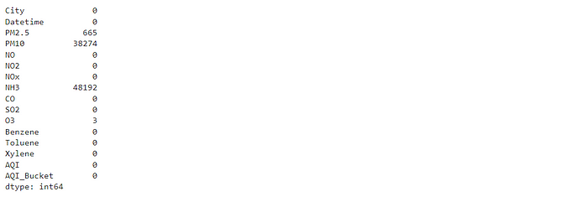

ADVANTAGES

**Improves health protection** – Monitoring air quality aids in safeguarding our health by alerting us to harmful pollutants that can cause sickness or worsen existing health conditions.

**Reduces pollution effects** – It helps in minimizing the impact of pollution by providing data to inform strategies for reducing harmful emissions.

**Guides environmental policies** – By offering robust data on air pollution levels, it serves as a crucial tool in shaping environmental policies and regulations.

**Enhances indoor comfort** – It also contributes to improving indoor comfort, as monitoring can detect pollutants within homes or workplaces, guiding efforts to improve air quality.

**Supports climate change studies** – Lastly, it plays an essential role in studying climate change by tracking greenhouse gas emissions and other climate-altering pollutants.

DISADVANTAGES

**Can be expensive to install** – Air quality monitoring systems can be heavy on the pocket due to the high cost of installation.

**Needs regular maintenance** – These systems require frequent upkeep to ensure they function properly, which can be time-consuming.

**May give inaccurate readings** – There’s a chance that these devices might not always provide precise data, leading to potential misinterpretation.

**Limited in spatial coverage** – These systems may not cover a large area, restricting the scope of air quality assessment.

**Can’t monitor all pollutants** – The ability of these systems is limited and they may not be capable of tracking every type of air pollutant.

CONCLUSION

As the field of air quality monitoring continues to evolve, sustained emphasis on innovative feature engineering methodologies and advancements in data analytics will be indispensable for unraveling the intricate dynamics of air quality. By fostering a culture of continuous improvement and knowledge exchange, feature engineering serves as a catalyst for fostering resilient, data-driven decision-making processes and cultivating a healthier, more sustainable living environment for present and future generations.